|  |  |  |  |
| --- | --- | --- | --- |
| Angol szóbeli vizsga | Középszint | 1.Vizsgafeladat | Bevezető interjú |

**1. Vizsgafeladat -vizsgáztatói példány**

**Bevezetés (nem értékeljük)**

Mielőtt a tényleges szóbeli vizsga elkezdődik, egy rövid (kb. egyperces) bemelegítő beszélgetés szükséges.

Vizsgáztató:

* Did you sleep well?
* How are you today?
* What did you do yesterday evening?
* When did you get up?
* Is it the first time you are taking an exam?
* How did you come here?
* Are you planning to have a party after the exam?
* ( If “no”: ) What are you going to do after the exam?

*Now I am going to ask you a few questions. If you can’t understand me, I can repeat the question once. Let’s get started:*

**Tényleges vizsga (ettől a résztől értékeljük):**

Vizsgáztató:

We are going to talk about free time and culture.

A Which one do you prefer: reading books or watching films/series? Why?

**I prefer watching films because I don’t like reading. I like …films. I sometimes go to the cinema to Kaposvár.**

B What kind of art do you like best? Why?

**There are different kinds of art, for example sculpture, painting, film art, graffiti...**

**I like … because…**

C Do you know museums in Dombóvár? Where are they? What can you see there?

**In Dombóvár there are three museums. There is a historical museum in the centre. I’ve never been there. There is another museum called István Fekete. There you can see some interesting objects from the writer’s life. The third museum can be found in Szigeterdő, where you can see the collection of different bricks.**

Thank you very much.

That’s the end of your first task.

|  |  |  |  |
| --- | --- | --- | --- |
| Angol szóbeli vizsga | Középszint | 2.Vizsgafeladat | Szituációs feladat |

# 2. Vizsgafeladat - vizsgáztatói példány

A vizsgáztató átadja a vizsgázónak a vizsgázó feladatlapját. A vizsgázó kb. fél percig készülhet.

A vizsgázó példánya

You are going to study at university in Budapest and want to share your room with a foreign student (the examiner). Talk to your roommate about the following points:

- your room / furniture

- what electrical appliances you have and what you need

- sharing the housework

- sharing the bills / the rent

Your examiner will also make some comments.

Prompts for the interlocutor:

* So, now we should discuss what furniture we have and what we need to buy for our new room. I have some furniture in my room (two beds, a wardrobe, a desk). Would you like to bring any pieces of furniture? Do you need to buy any pieces of furniture?
* **Yes, I need to buy a desk and a bedside table. I also need an armchair, because I like reading sitting in it.**
* In the kitchen I have a toaster, a coffee maker, there is a fridge, a cooker. Do you think we need a dishwasher?
* **Yes, I think so. If we can afford it, we should buy some, because I don’t like doing the washing-up.**
* What can you help in the kitchen and in the rooms?
* **I like cooking. I can also do the hoovering.**
* Ok, then I will all do the other housework. How can we share the bills and the rent?
* **I will pay half of the rent and the bills, too.**
* Allright. I hope we will have a great time together.

|  |  |  |  |
| --- | --- | --- | --- |
| Angol szóbeli vizsga | Középszint | 3.Vizsgafeladat | Önálló témakifejtés |

#### **3. Vizsgafeladat - vizsgáztatói példány**

A vizsgáztató átadja a vizsgázónak a vizsgázó feladatlapját. A vizsgázó kb. fél percig készülhet.

# A vizsgázó példánya

These two pictures show different bad habits which destroy our health. Compare and contrast them. Include the following points:

- types of bad habits you know

- why we have them

- possible dangers

- what you do (should do) to stay healthy and fit

**There are different kinds of bad habits, for example smoking, gambling, playing too much…**

**I think people have bad habits because they live a stressful life and they these activities to stay calm. However, they can become addicted to these bad habits easily.**

**If you smoke too many cigarettes, you can become ill. You can even have cancer. If you use your computer too much, you can become isolated. If you sit too much in front of your computer and don’t do exercise, you can become overweight.**

**I think people should spend time doing exercise, they should eat healthy food and drink healthy drinks.**

**I do some sports. I ….**

Prompts for the interlocutor:

* Have you ever tried to get rid of bad habits?
* Do you have a favourite computer game? Please describe it.
* Why do you think many people like gambling games?
* How can bad habits be prevented?
* How do bad habits (e.g. smoking, comfort eating) influence one’s health/human relationships? Give examples.

**THANK YOU, THIS IS THE END OF YOUR EXAMINATION.**

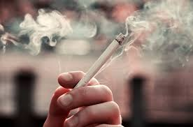

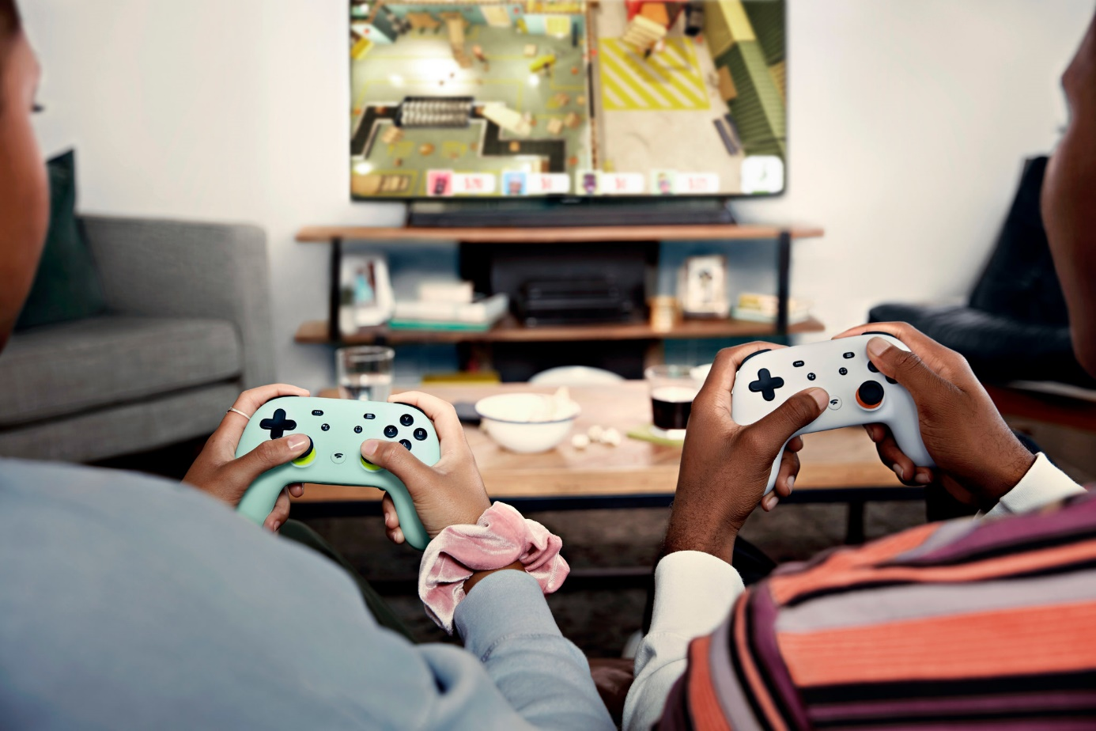

|  |  |  |  |
| --- | --- | --- | --- |
| Angol szóbeli vizsga | Középszint | 2.Vizsgafeladat | Szituációs feladat |

# 2. Vizsgafeladat - vizsgázói példány

A vizsgázó példánya

You are going to study at university in Budapest and want to share your room with a foreign student (the examiner). Talk to your roommate about the following points:

- your room / furniture

- what electrical appliances you have and what you need

- sharing the housework

- sharing the bills / the rent

Your examiner will also make some comments.

|  |  |  |  |
| --- | --- | --- | --- |
| Angol szóbeli vizsga | Középszint | 3.Vizsgafeladat | Önálló témakifejtés |

#### **3. Vizsgafeladat - vizsgázói példány**

# A vizsgázó példánya

These two pictures show different bad habits which destroy our health. Compare and contrast them. Include the following points:

- types of bad habits you know

- why we have them

- possible dangers

- what you do (should do) to stay healthy and fit

